Scale Replica

Q.) How do we update our ReplicaSet to scale to 6 replicas.

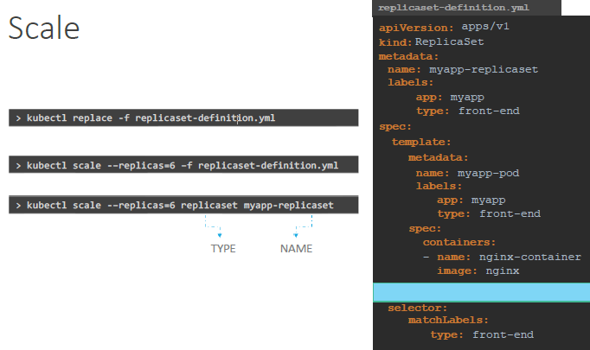

**There are multiple ways to do it.**

1. Update the number of replicas in the definition file to 6.
   * Run either of the below commands
     + ***k replace -f writer-rs.yml, or***
     + ***k apply -f writer-rs.yml***
2. Run either of the below commands
   * k scale - -replicas=6 -f writer-rs.yml
   * k scale - -replicas=6 replicaset writer-rs

However, remember that using the file name or ReplicaSet name as input will not result in the number of replicas being updated automatically in the file.